EXP NO:

MINI-PROJECT 2
HEALTHCARE DATA ANALYTICS DASHBOARD

DATE:

AIM:
To analyze and visualize healthcare data using Microsoft Power BI and Tableau by performing data cleaning and transformation, applying relevant calculations, creating meaningful visualizations, and developing interactive dashboards to identify patient trends, treatment costs, hospital performance, recovery patterns, and other important healthcare insights.
PROBLEM STATEMENT:
To analyze healthcare data containing information about patients, hospitals, departments, diagnoses, treatments, admissions, insurance, treatment costs, and recovery status using SQL for data management and Power BI and Tableau for analysis and visualization. The project aims to clean and transform the data, perform relevant calculations, and develop interactive dashboards to identify patient trends, treatment costs, department performance, hospital patterns, and recovery outcomes, thereby supporting effective healthcare decision-making.
DATA DESCRIPTION:
The healthcare dataset contains 500 patient records with information related to patient demographics, hospital admissions, diagnoses, treatments, costs, insurance, and recovery outcomes. The dataset is stored in SQL and can be connected to Power BI and Tableau for analysis and visualization.
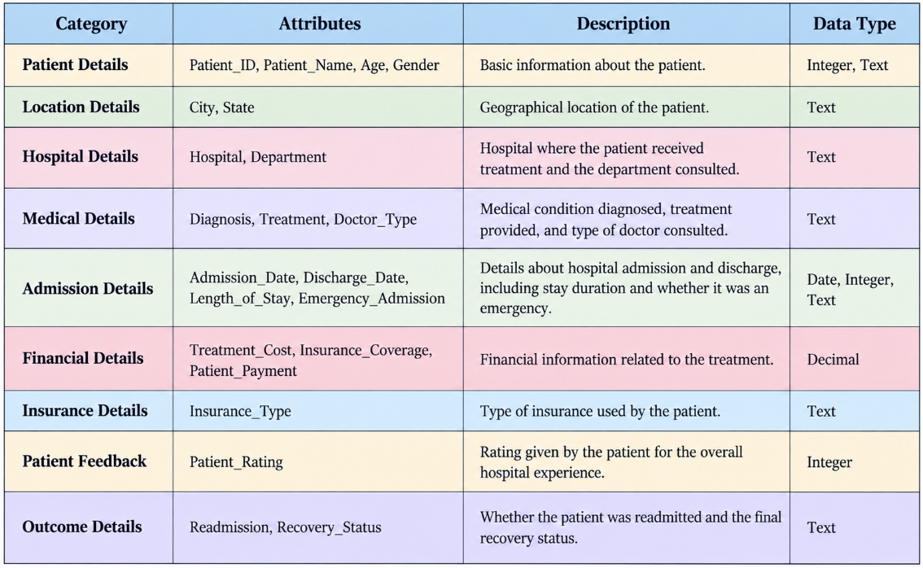
DATA SOURCE:
The healthcare dataset used in this project is derived from a healthcare dataset available on Kaggle. It was adapted and structured for healthcare data analysis by organizing information related to patients, hospitals, departments, diagnoses, treatments, admissions, insurance, treatment costs, and recovery outcomes.
Source: Kaggle – Healthcare Dataset
Data Type: Structured healthcare data
Records: 500 patient records
Format: CSV/Excel, imported into MySQL and subsequently connected to Power BI and Tableau for analysis and visualization.
POWER BI DASHBOARD:
1)IMPORTING THE DATA FROM MYSQL:
Algorithm
- Open Power BI Desktop.
- Select Get Data → MySQL Database.
- Enter the MySQL server and database details.
- Select the healthcare data table from the Navigator.
- Click Transform Data to import the dataset into Power Query.
Output:
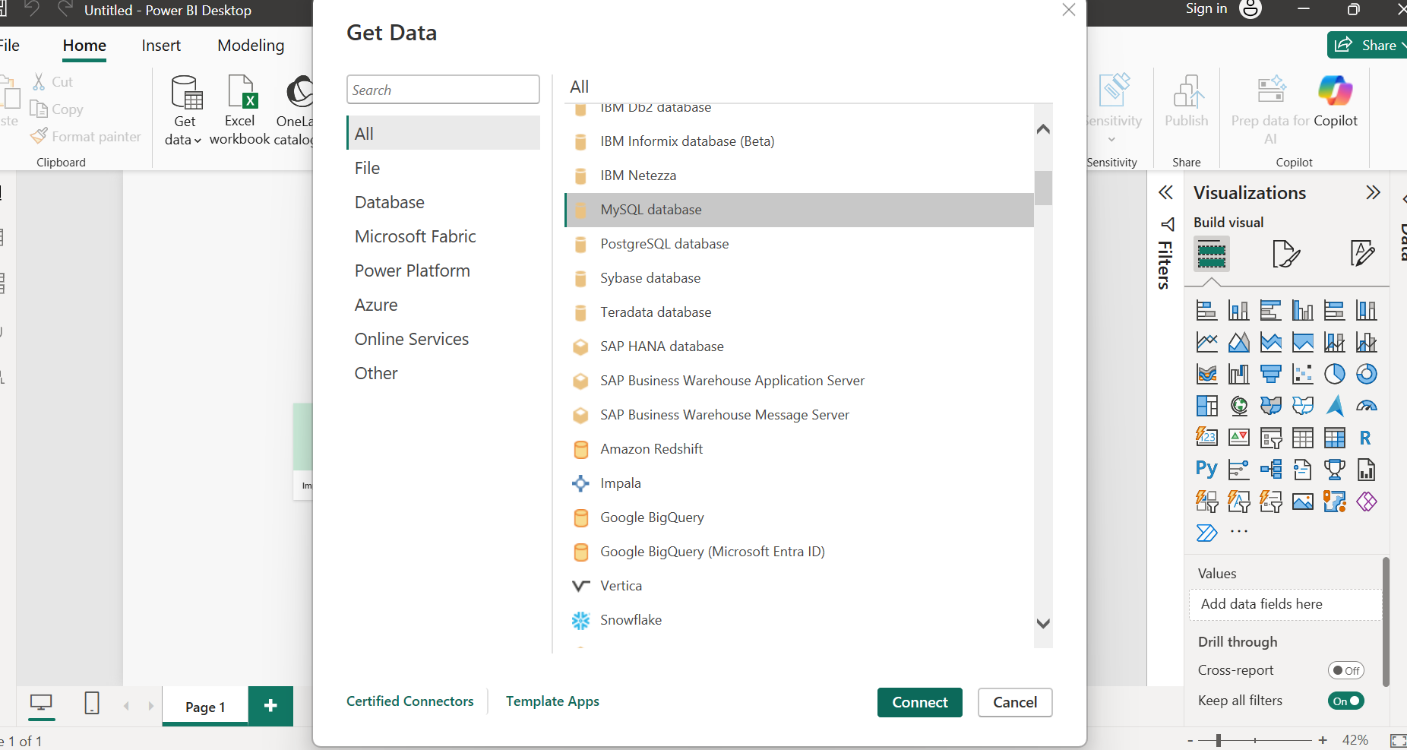
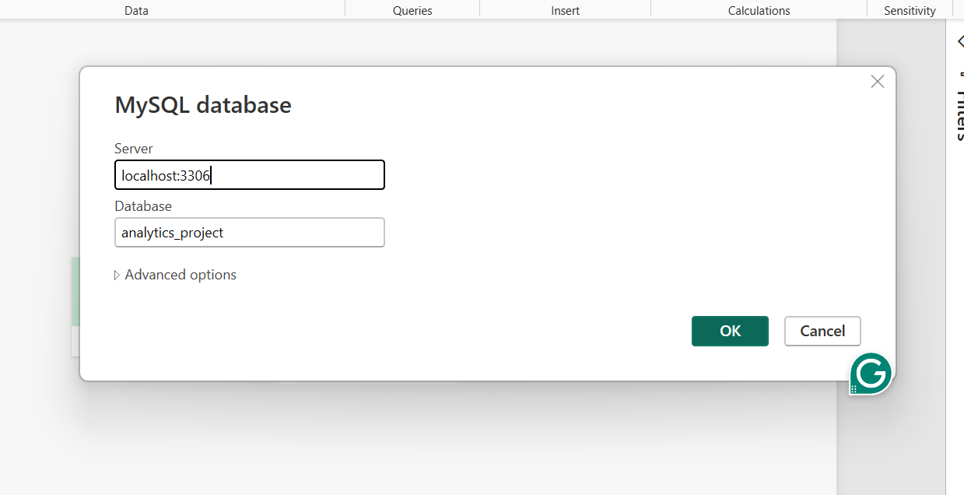
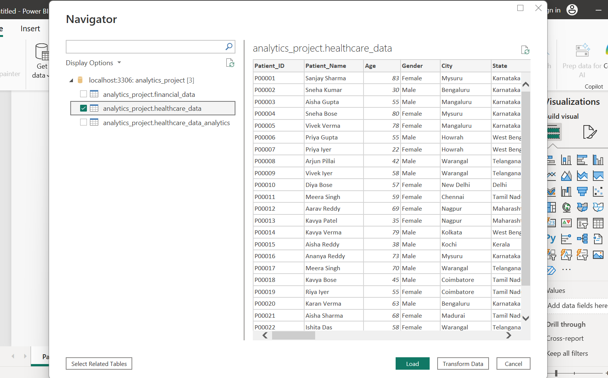
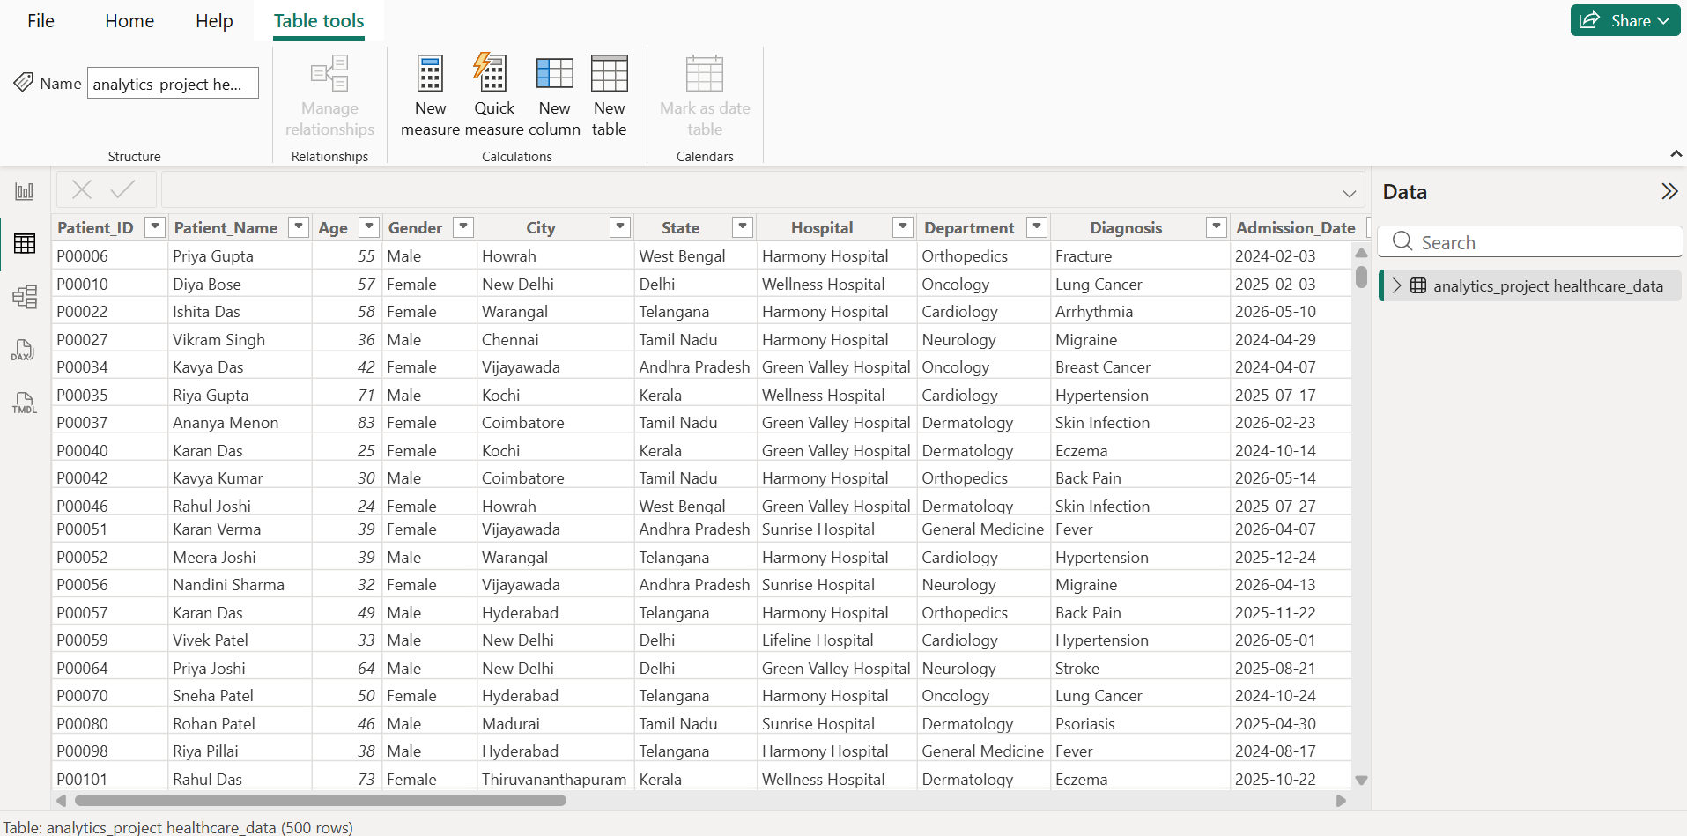

2)DATA CLEANING AND TRANSFORMATION
Algorithm
- Open the healthcare dataset in Power Query Editor.
- Check for blank rows, duplicate records, and missing values.
- Remove unnecessary columns or rows, if present.
- Assign appropriate data types to each column.
- Verify the cleaned dataset and apply the changes.
Output:
1)Changing the data type of admission date and discharge date to Date:
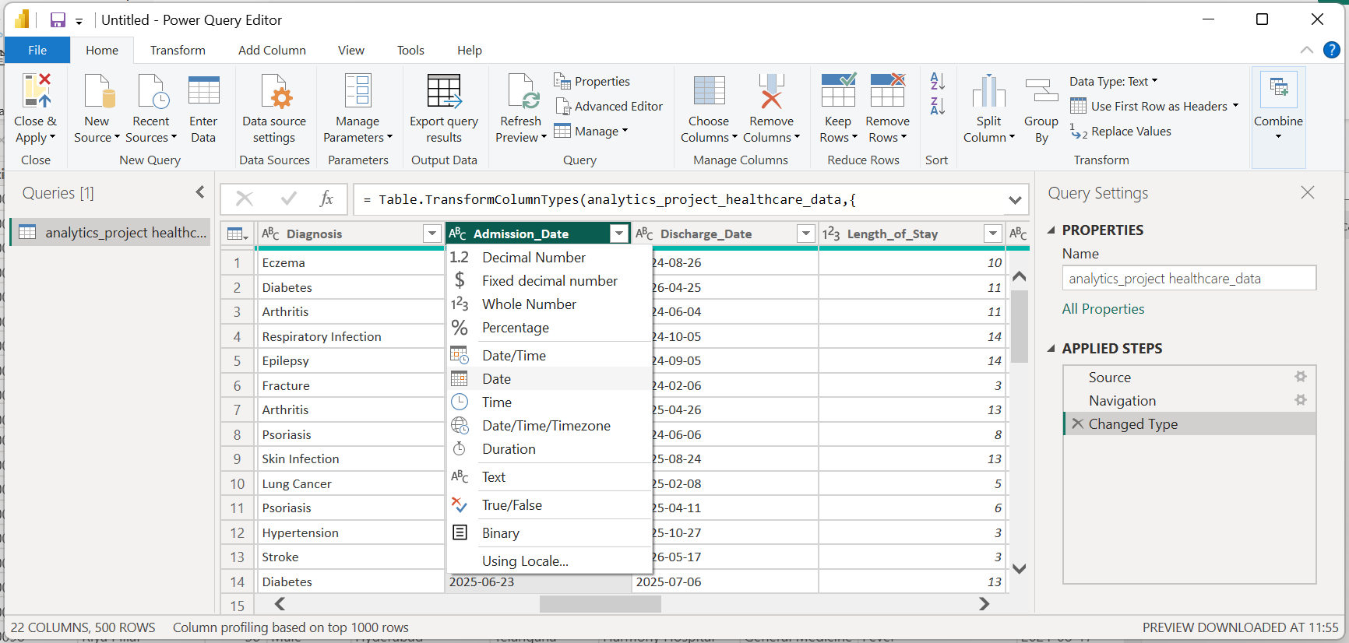
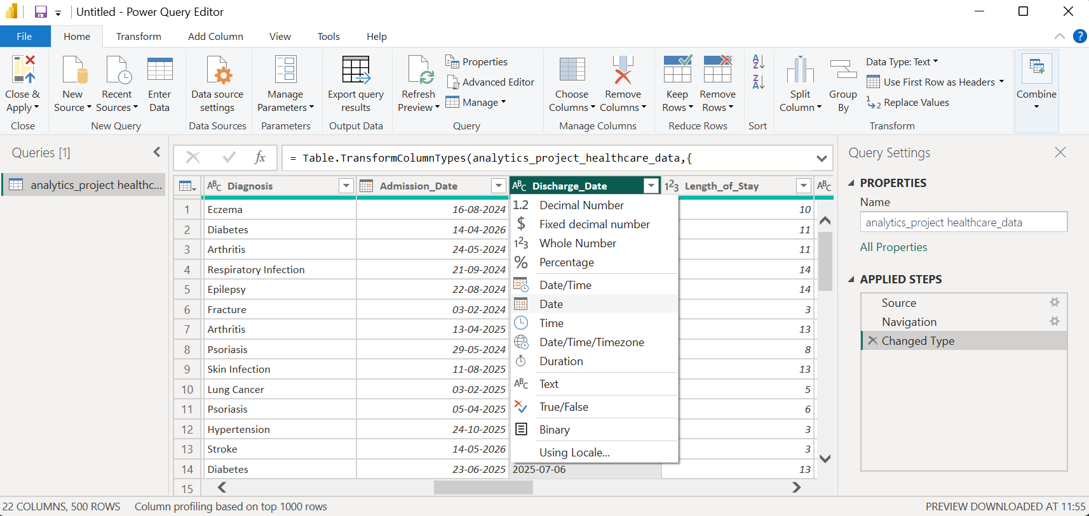
2)Removing empty rows:
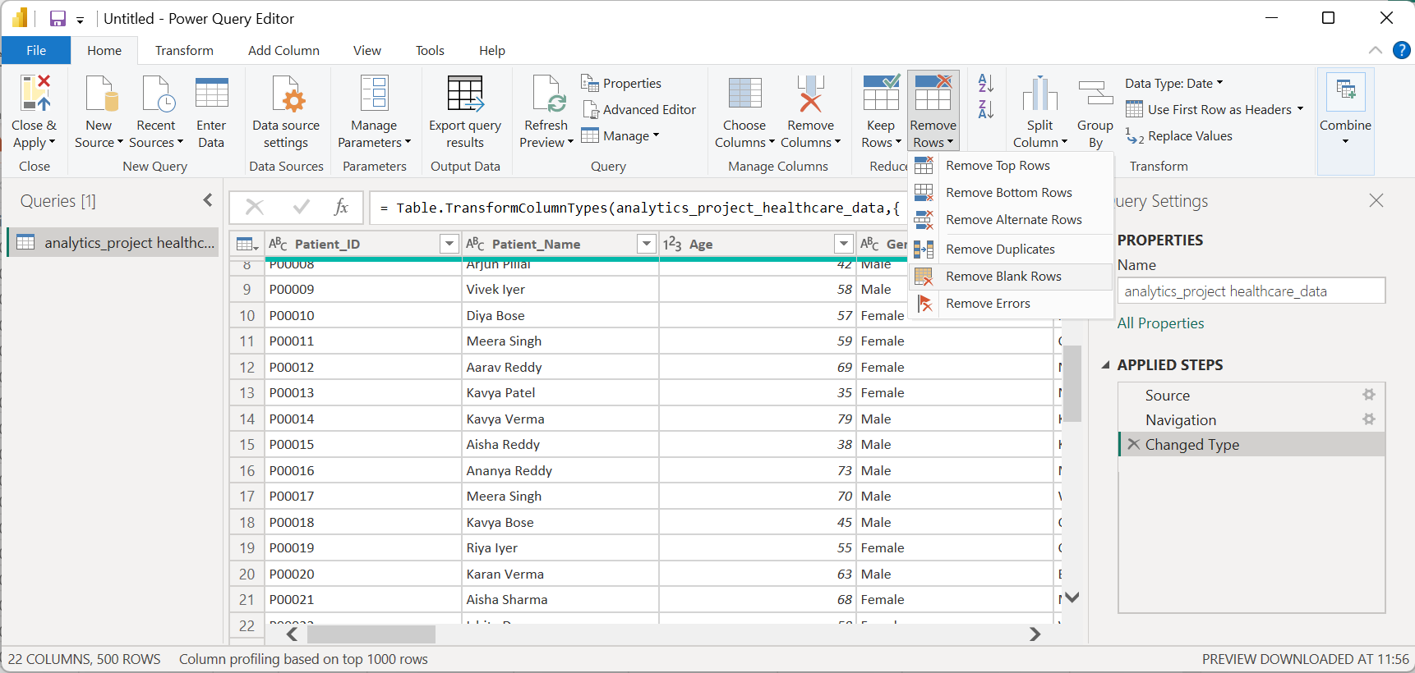
3)Removing duplicate rows:
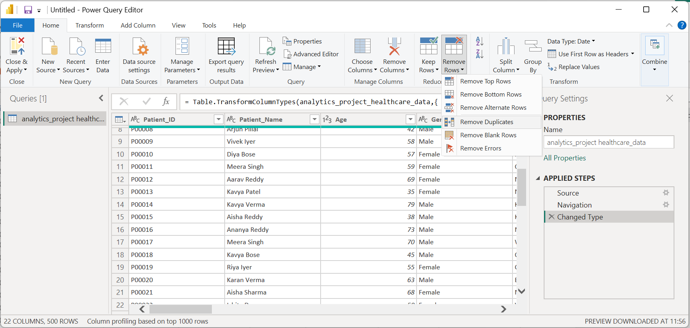
4)Applying all changes and closing
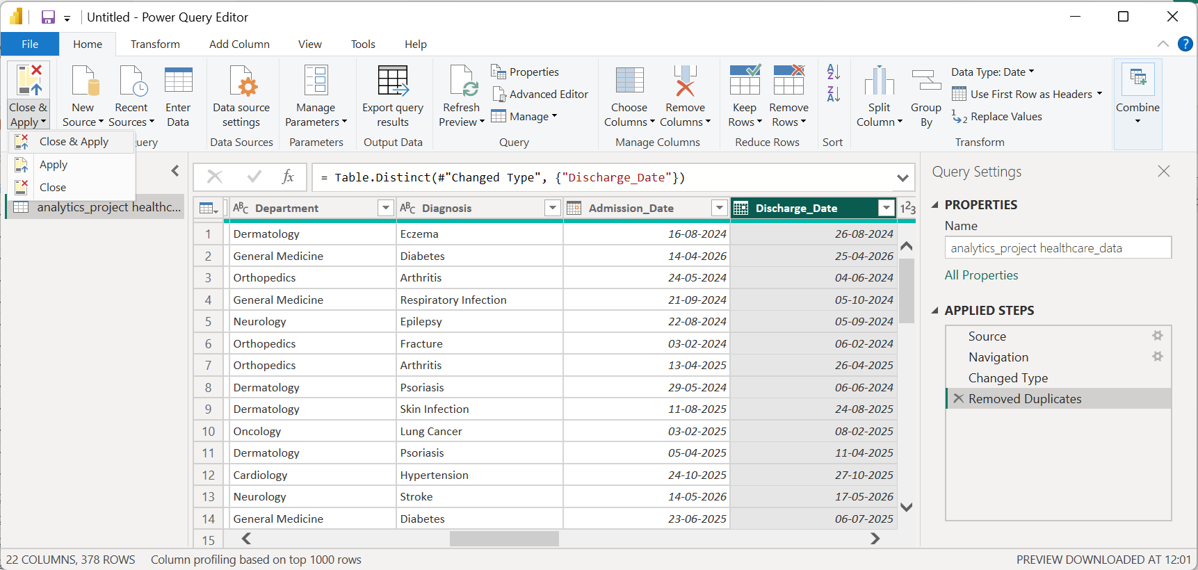

3)DATA MODELLING:
Algorithm
- Open Modeling → New Table.
- Create a Date table using DAX.
- Create a relationship between the Date table and the healthcare table.
- Verify the relationship in Model View.
Output:
1)Creating the date table:
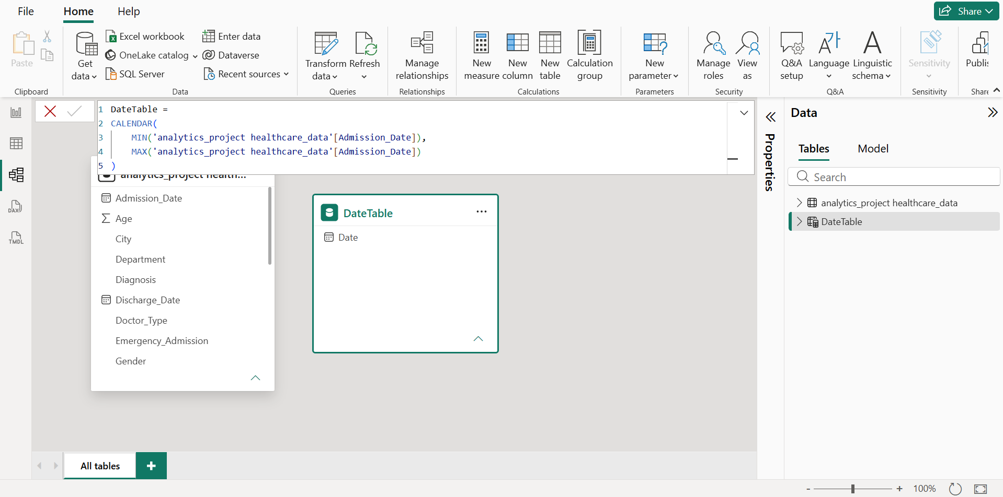
2)Setting the relationship between the table and setting the relationship as one-to-many and cross-filter direction as single:
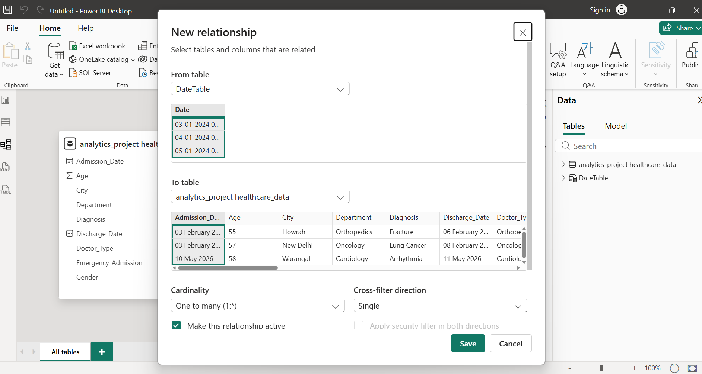
3)Create data model
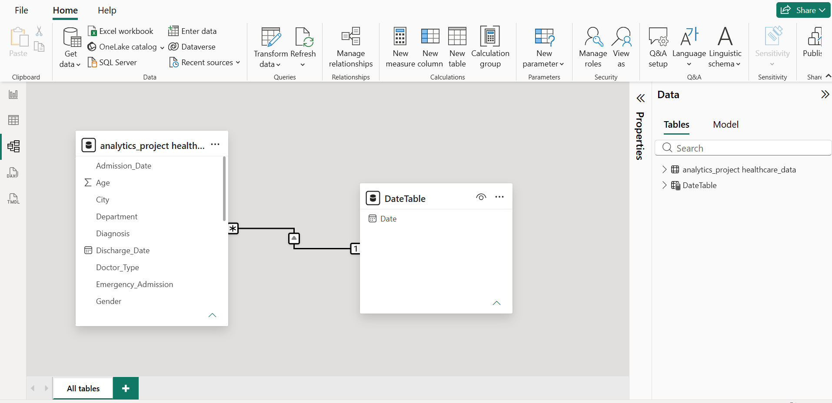

4)CREATE CALCULATED COLUMNS:
Algorithm
- Select the healthcare table.
- Create a calculated column using DAX.
- Classify patients based on age and treatment cost.
- Verify the newly created columns.
Output:
1)Creating age category column:
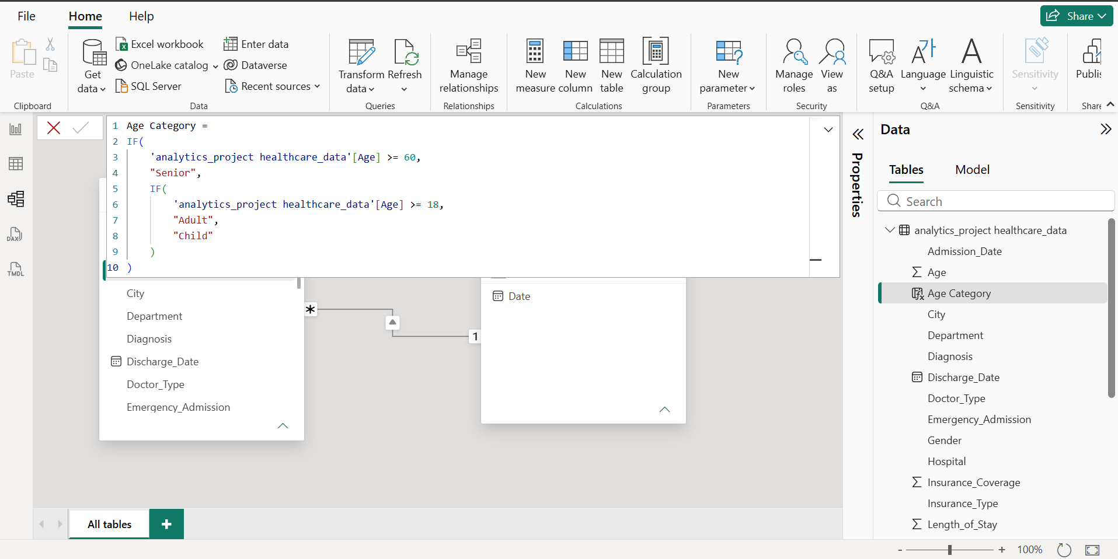
2)Creating cost category column:
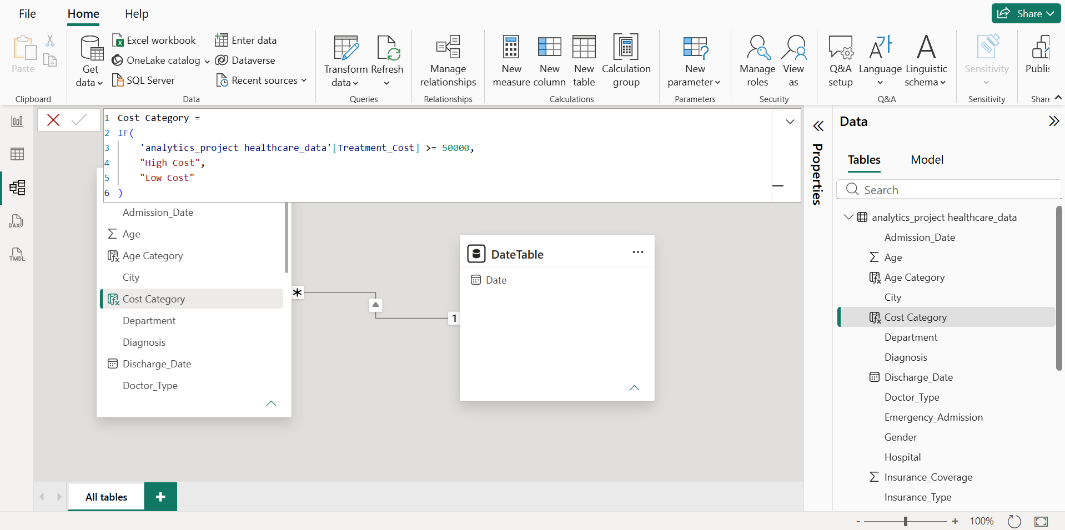
5)CREATE MEASURES USING DAX:
Algorithm
- Select the healthcare table.
- Create a new measure using DAX.
- Calculate patient count, treatment cost, average cost, and patient rating.
- Verify the measures.
Output
1)Total patients measure:
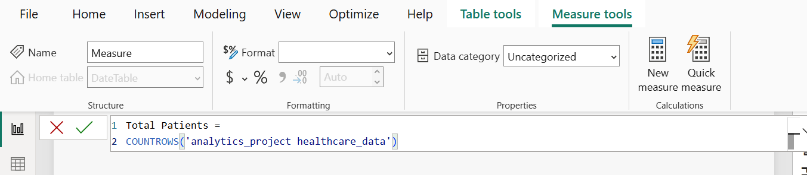
2)Total treatment cost measure:
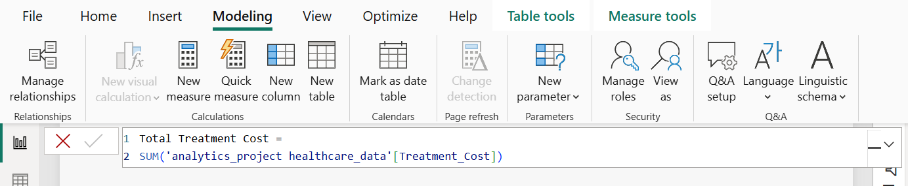
3)Average treatment cost measure:
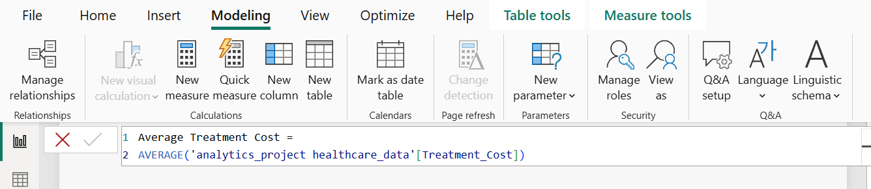
4)Average patient rating:
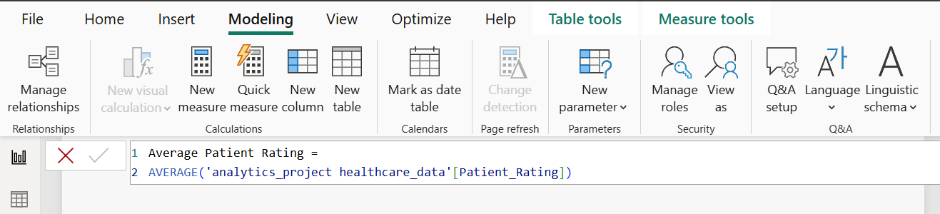

6)CREATING KPI CARDS:
Algorithm
- Open Report View.
- Insert a Card visual.
- Add a healthcare measure to the card.
- Repeat for the remaining measures.
- Arrange the cards neatly.
Output
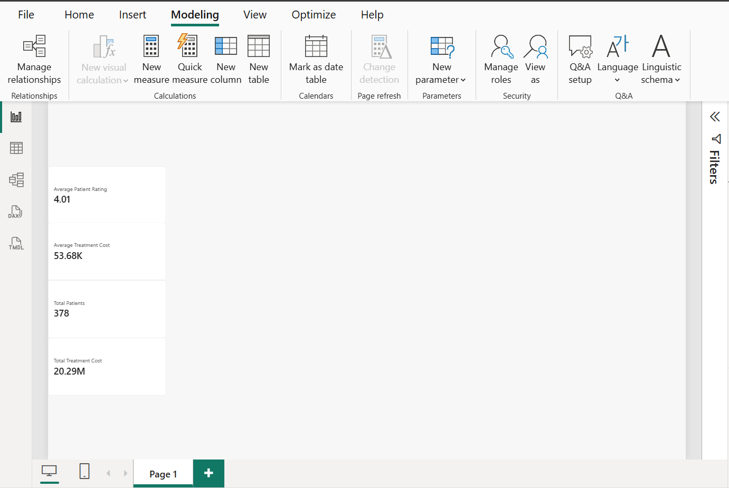
7)CREATING VISUALIZATIONS:
Algorithm
- Insert appropriate chart visuals in Report View.
- Add relevant healthcare fields and measures.
- Configure the charts to compare patient, cost, and outcome data.
- Add titles and data labels where appropriate.
- Arrange the five visuals neatly on the dashboard.
Output:
1)Recovery status distribution:
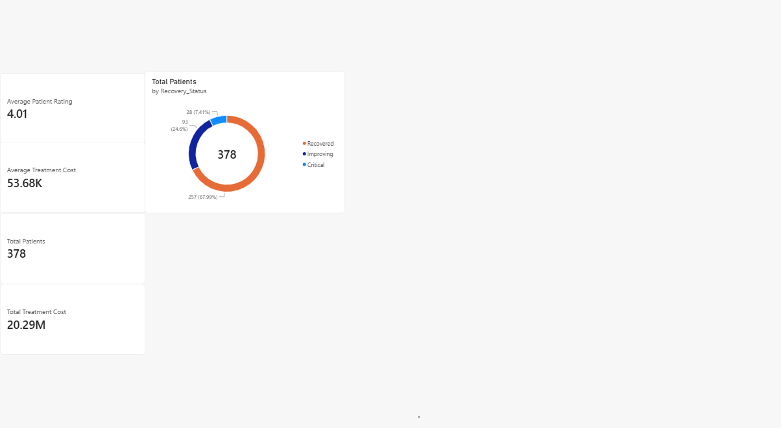
2)Healthcare-cost analysis – decomposition tree:
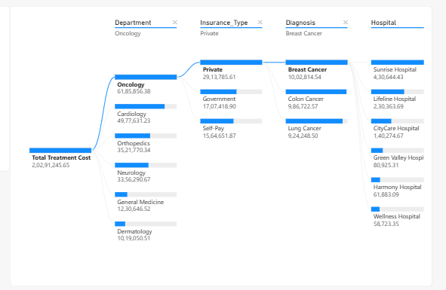
3)Emergency vs non-emergency admissions:
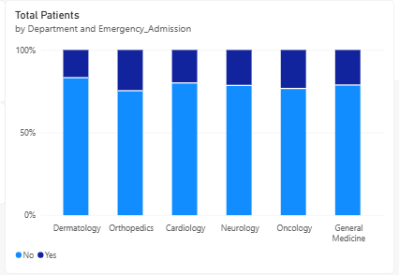
4)Readmission analysis by hospital:
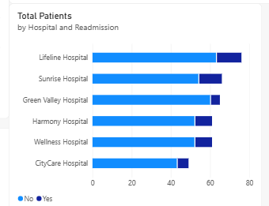
5)Treatment cost by insurance type – ribbon chart:
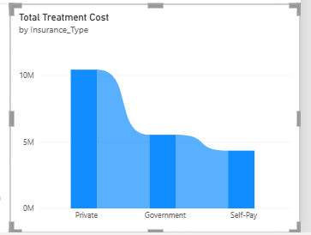
8)SLICERS AND FILTERS
Algorithm
- Insert slicer visuals in Report View.
- Add relevant healthcare fields to the slicers.
- Arrange the slicers neatly on the dashboard.
- Test the filters on the charts and KPI cards.
Output
1)Changes according to gender filter
- Female
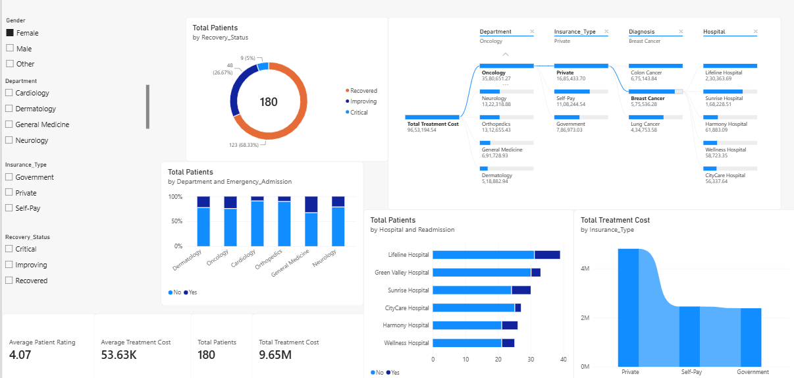
- Male
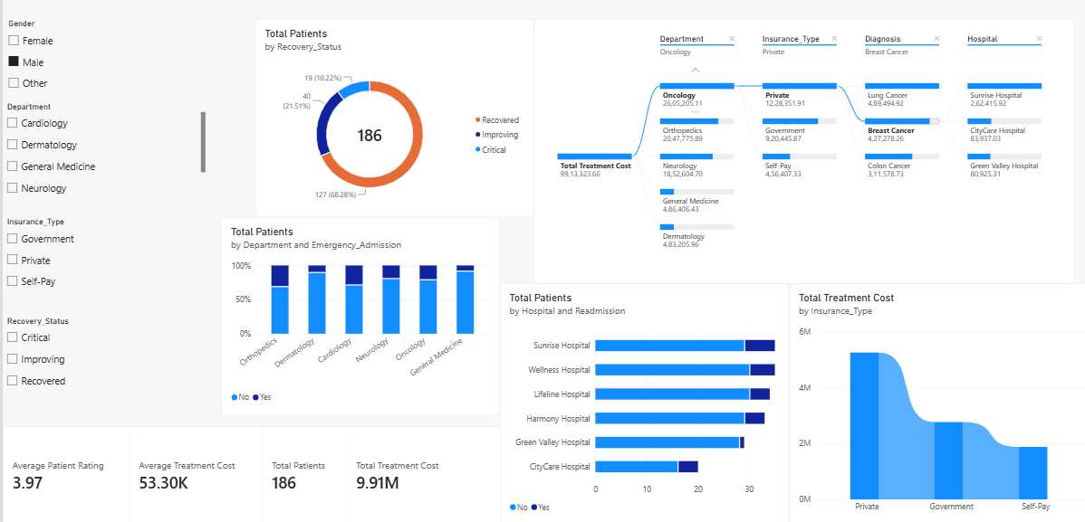
- Others
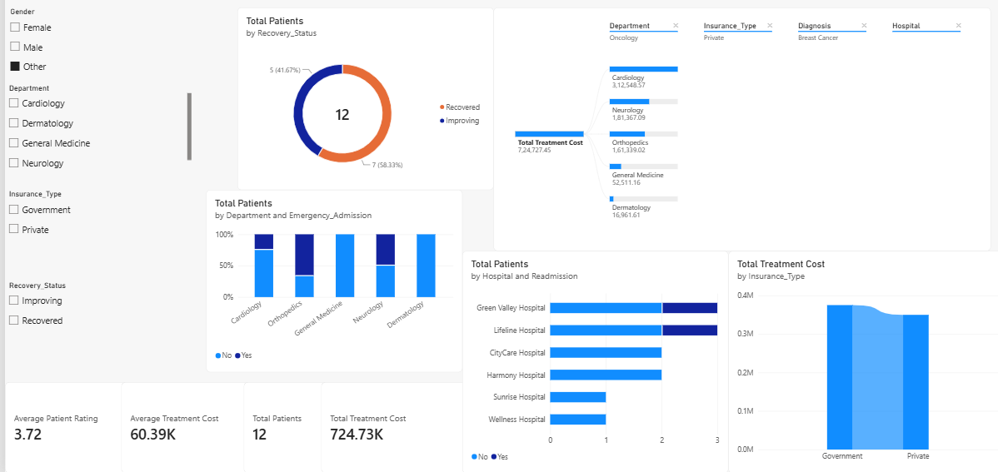
2)Changes according to Department filter
- Cardiology
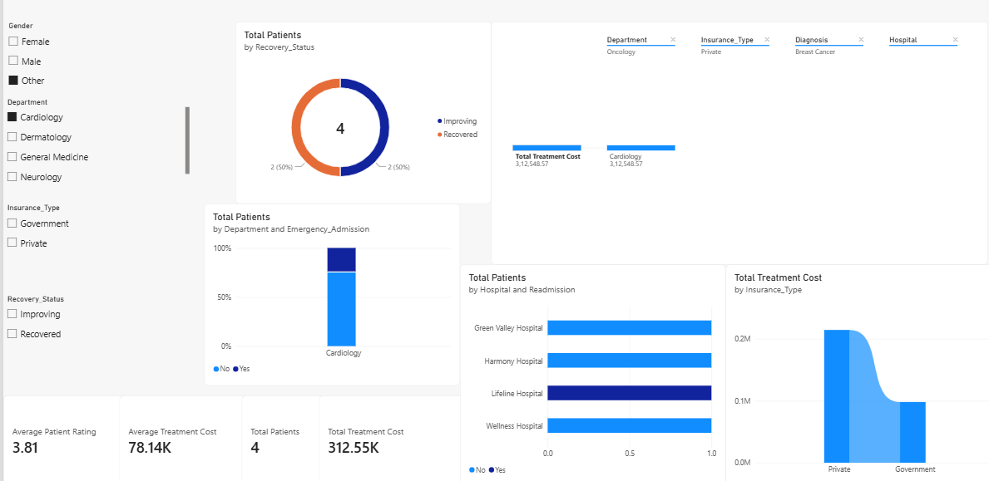
- Dermatology
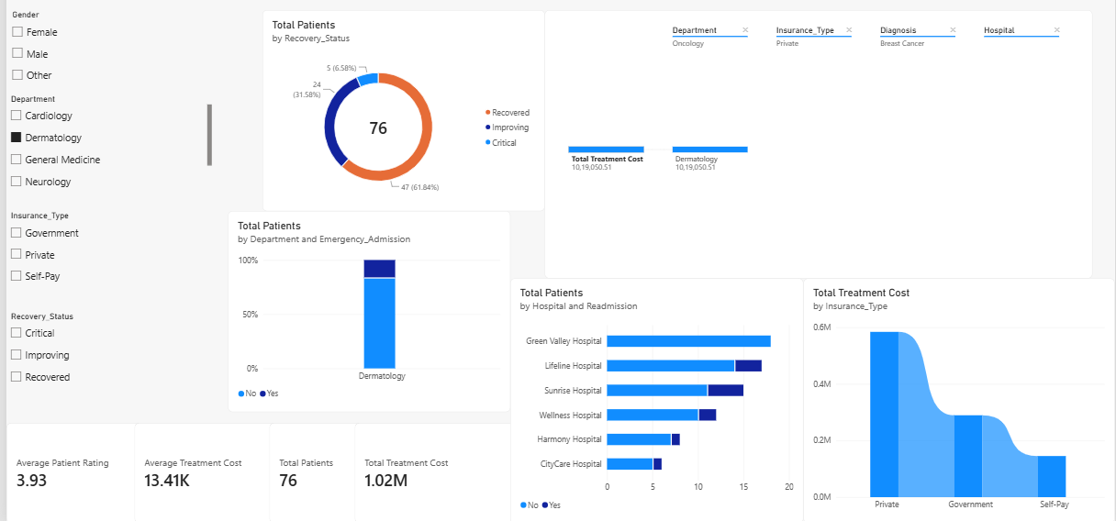
- General medicine
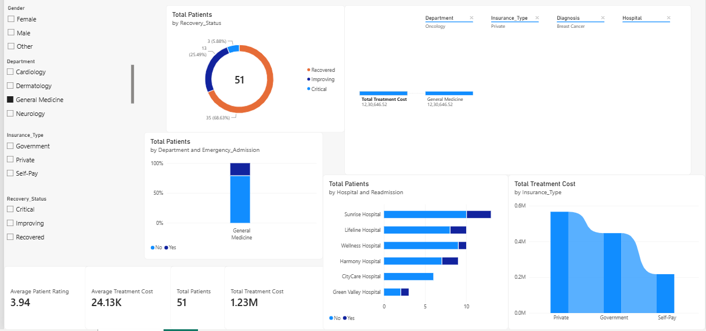
- Neurology
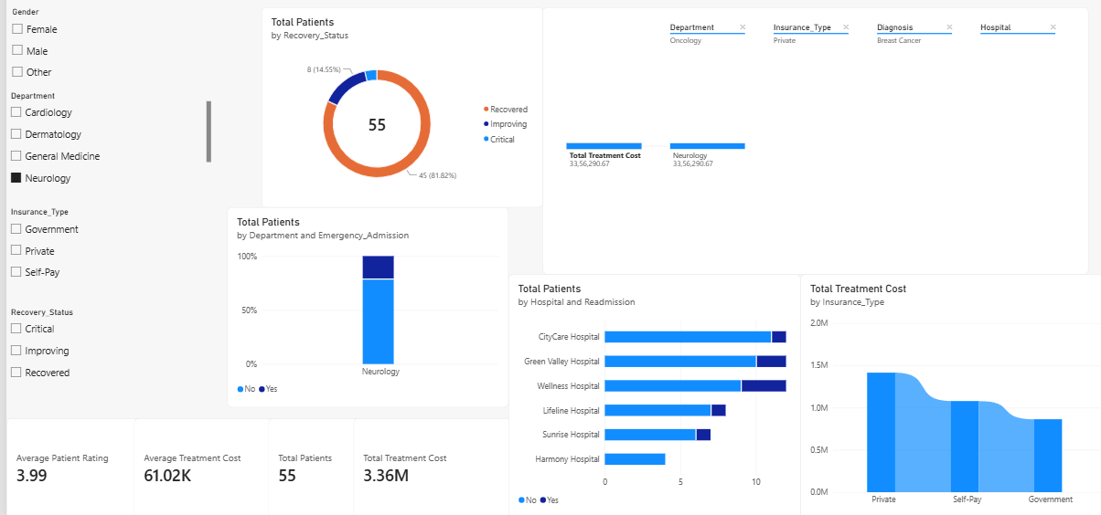
3)Changes according to insurance-type filter
- Government
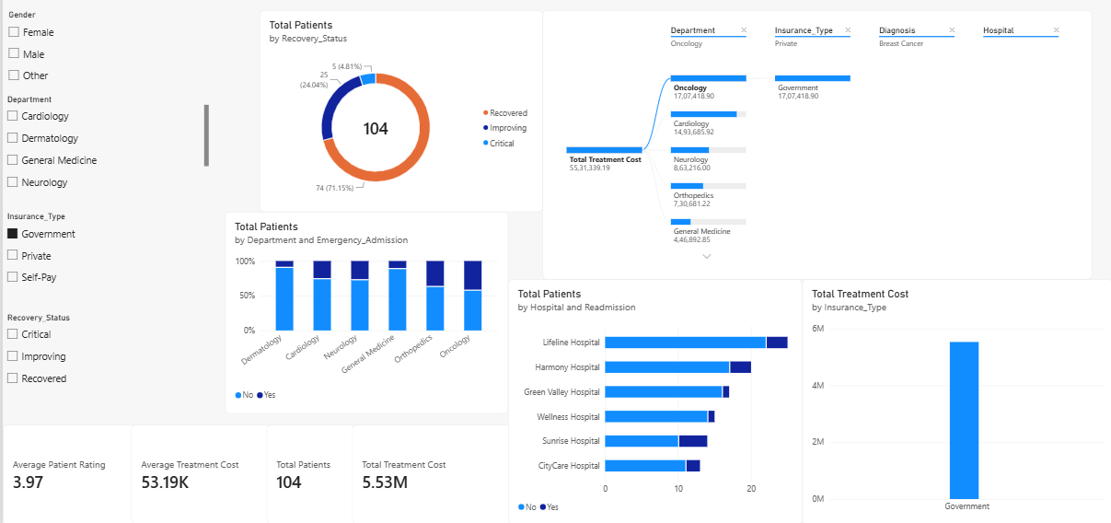
- Private
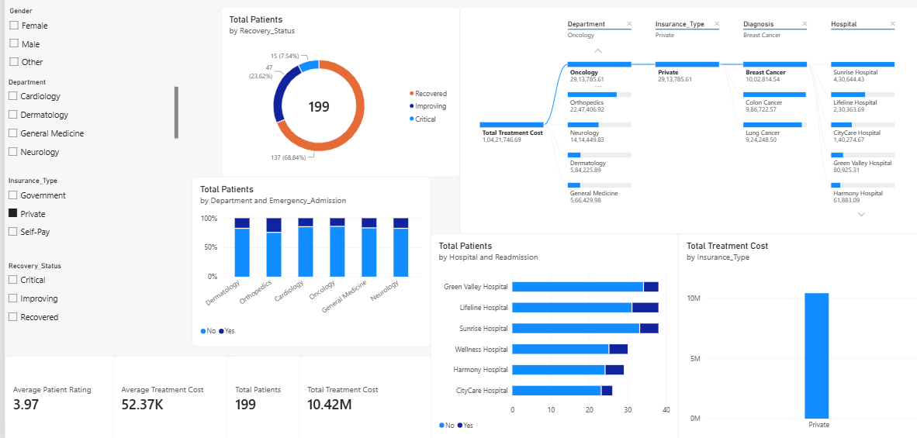
- Self-pay
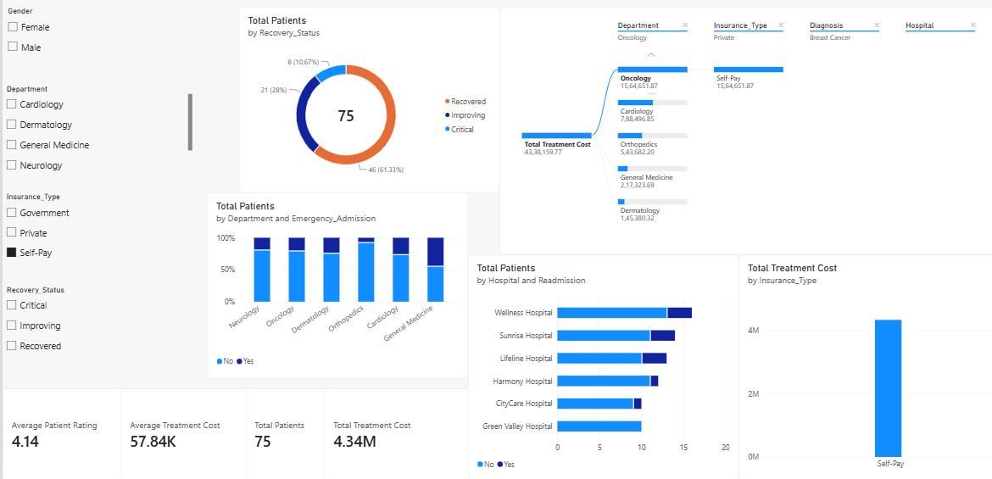
4)Changes according to recovery status
- Critical
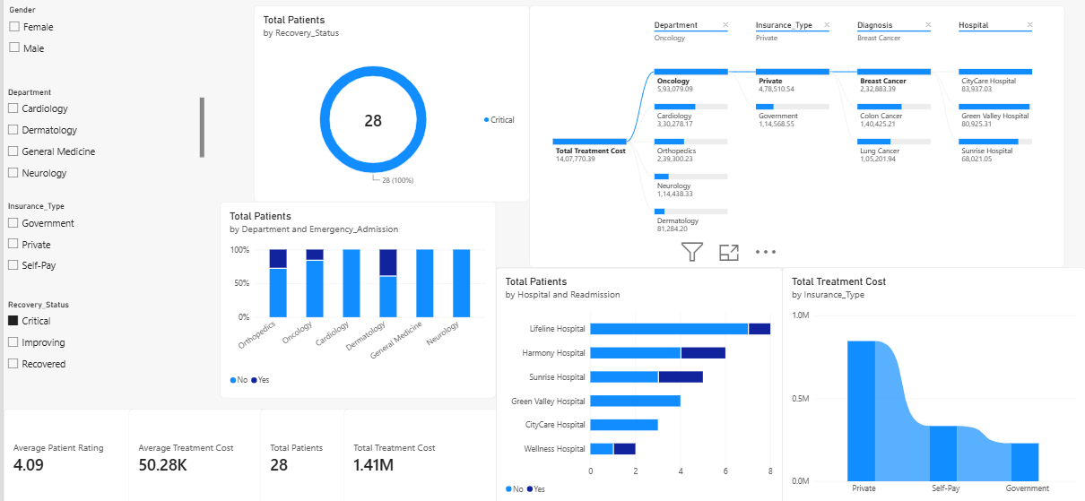
- Improving
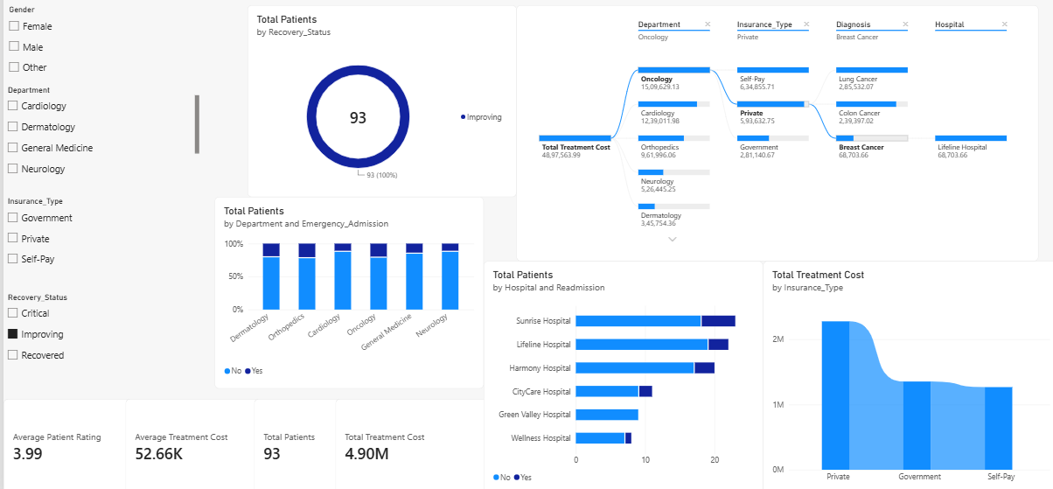
- Recovered
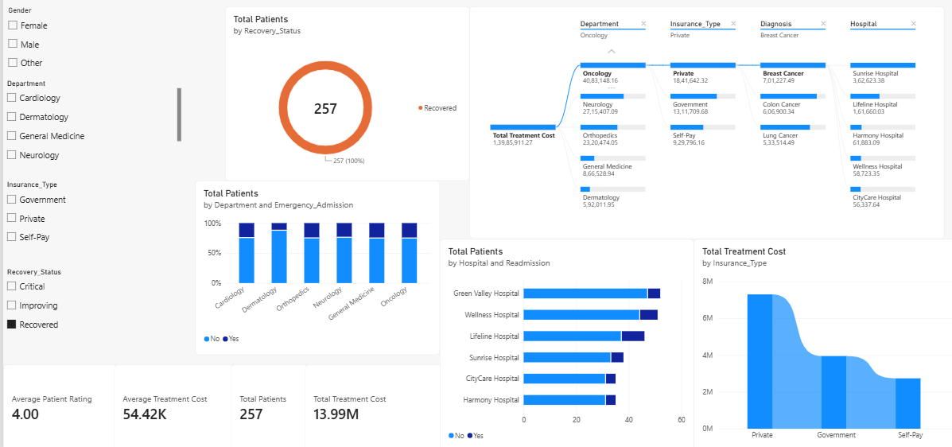
9)DASHBOARD FORMATTING AND INTERACTIVITY
Algorithm
- Arrange the KPI cards, slicers, and visualizations in a structured layout.
- Add a suitable dashboard title.
- Apply consistent formatting and data labels.
- Enable drill-down and cross-filtering.
- Check the complete dashboard for proper interaction and presentation.
Output
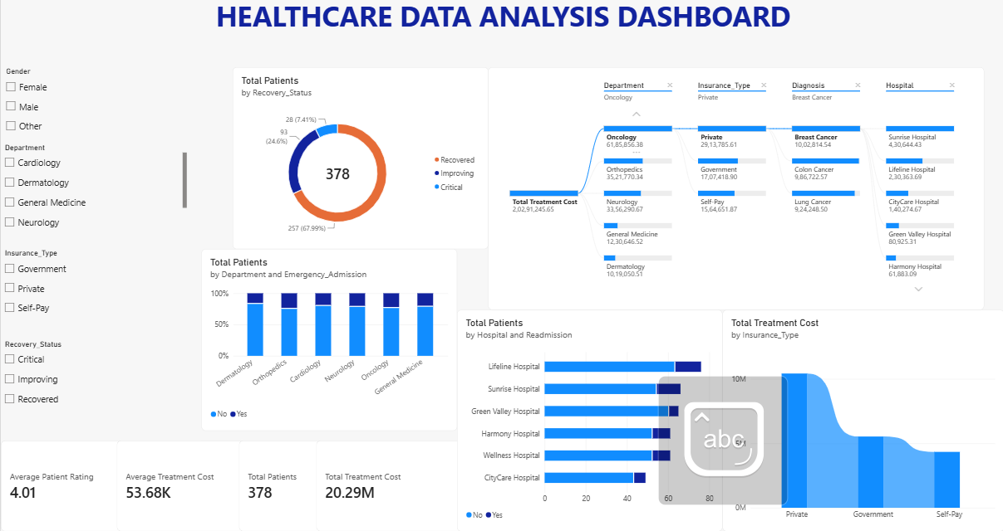

TABLEAU DASHBOARD:
1)CONNECTION TO MYSQL SERVER
Algorithm
- Open Tableau Desktop and select the MySQL connector.
- Enter the MySQL server and authentication details.
- Select the database containing the required dataset.
- Connect Tableau to the selected database.
- Select the appropriate healthcare table.
- Verify the data preview and field names.
- Open the worksheet to begin data preparation and analysis.
Output
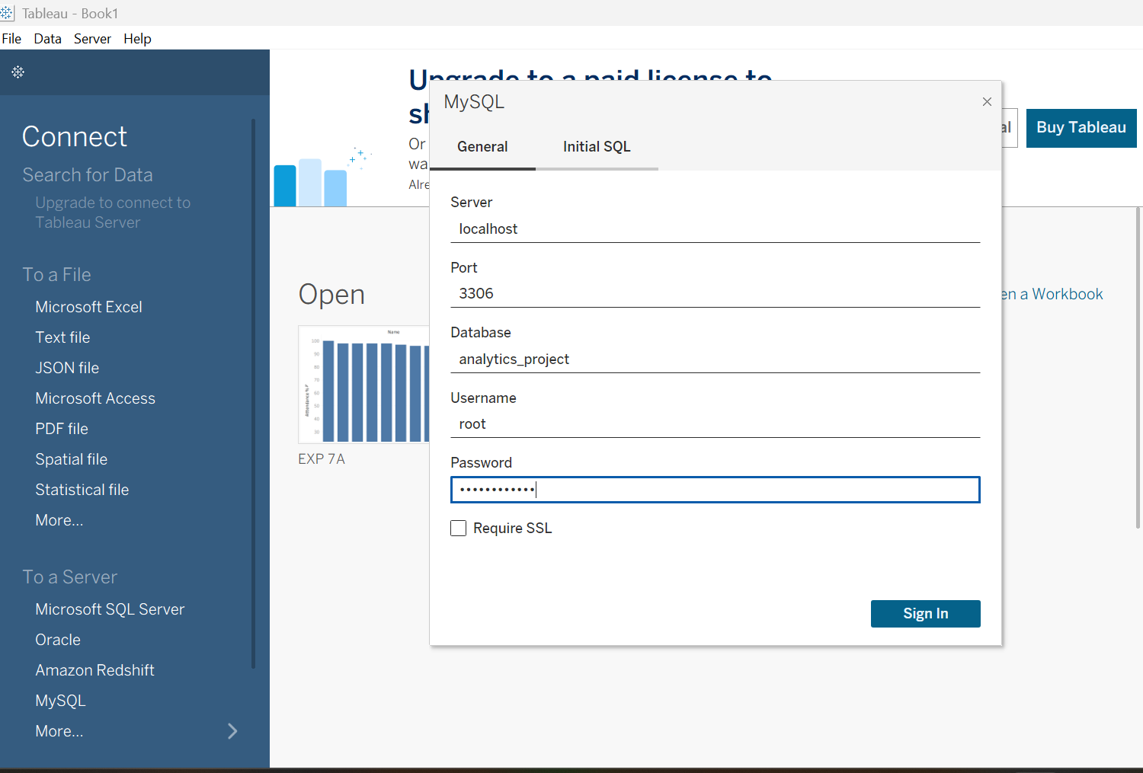
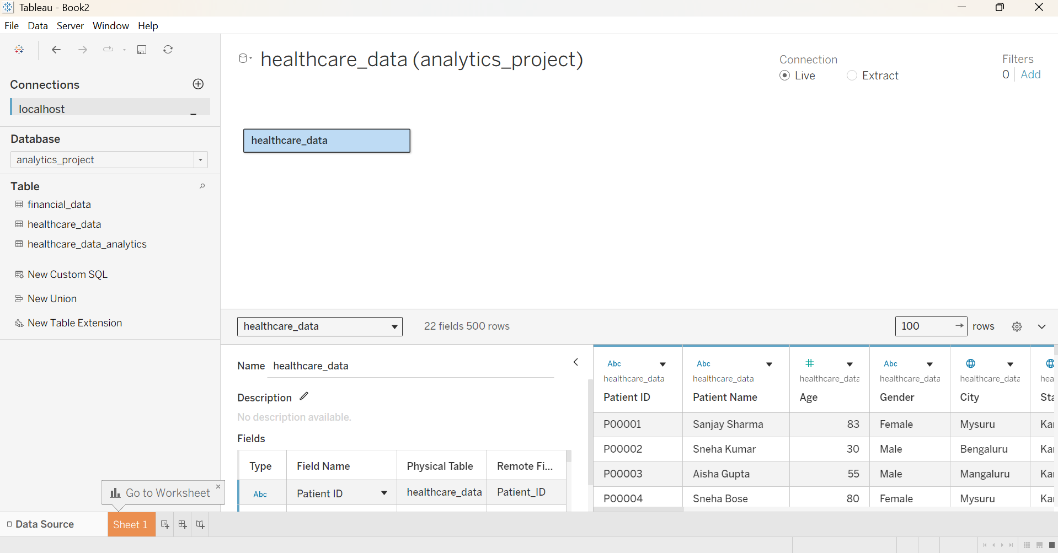
2)DATA PREPARATION AND INTEGRATION
Algorithm
- Connect the healthcare_data table from MySQL to Tableau.
- Verify the data types of date, numerical, and categorical fields.
- Check the data for missing or inconsistent values and make the required corrections.
- Organize the healthcare fields such as Patient, Hospital, Department, Treatment Cost, Insurance, and Recovery Status for analysis.
- Verify the prepared dataset and proceed to create worksheets.
Output
Datatype of admission date and discharge date columns changed to date, nulls removed and duplicates removed
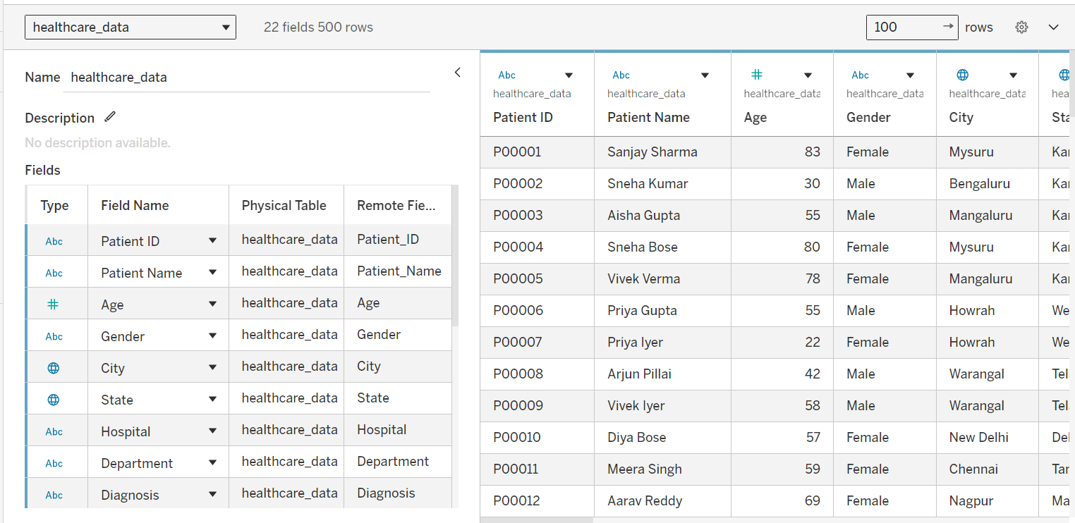
3)CREATE CALCULATED FIELDS
Algorithm
- Create a calculated field named Insurance Paid Percentage.
- Calculate the percentage of treatment cost covered by insurance.
- Create another calculated field named Stay Category.
- Classify patients into Short Stay, Medium Stay, and Long Stay based on their length of stay.
- Verify the calculated fields and use them for healthcare visualizations.
Output
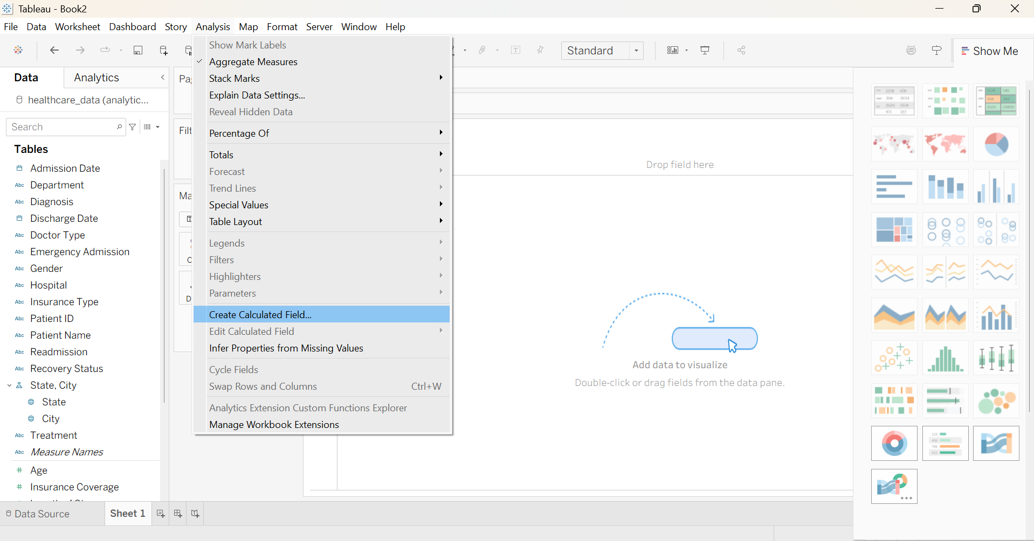
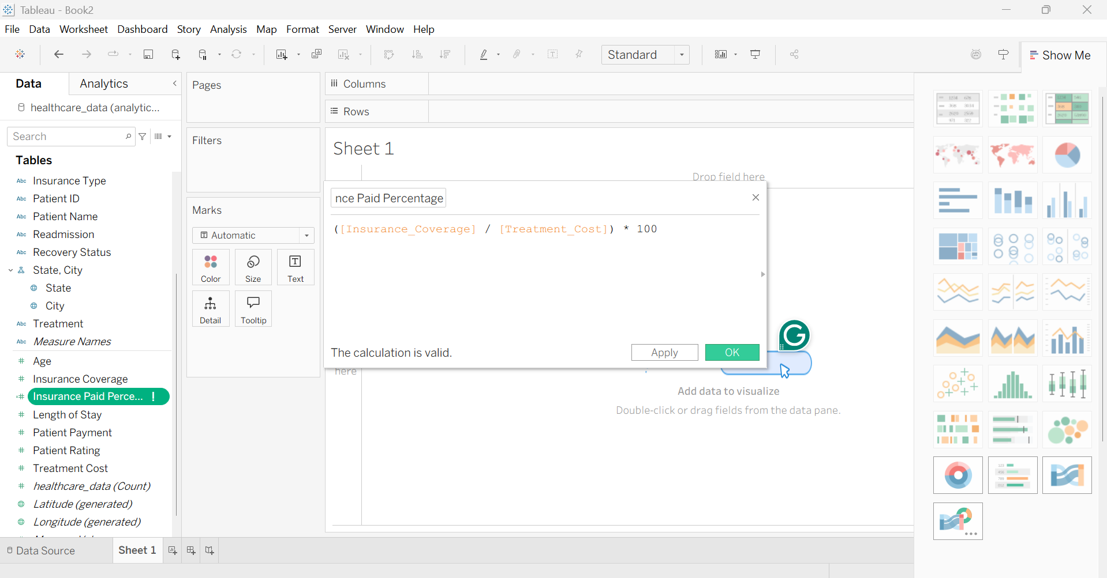
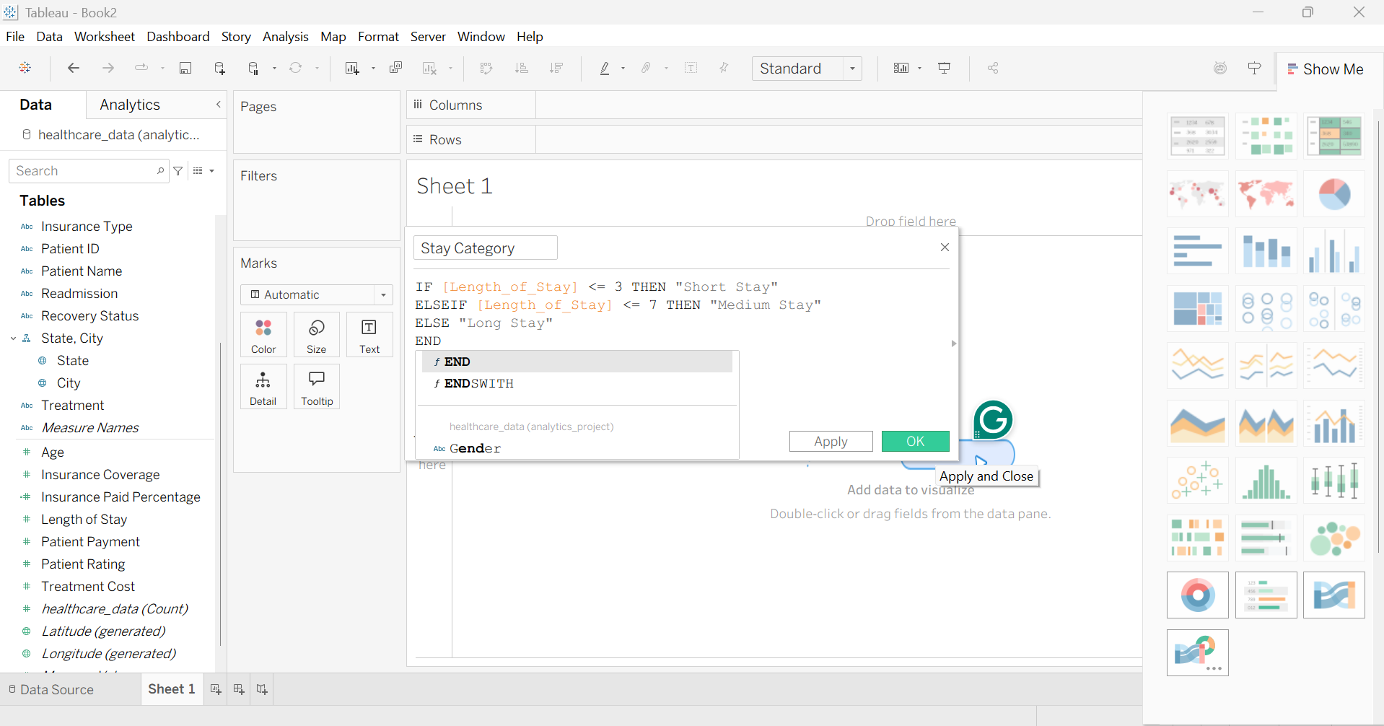
4)PARAMETERS
Algorithm
- Create a string parameter named Select Healthcare Metric.
- Add Treatment Cost, Insurance Coverage, and Patient Payment as parameter values.
- Create a calculated field based on the selected parameter.
- Use the calculated field to dynamically compare healthcare financial measures.
Output
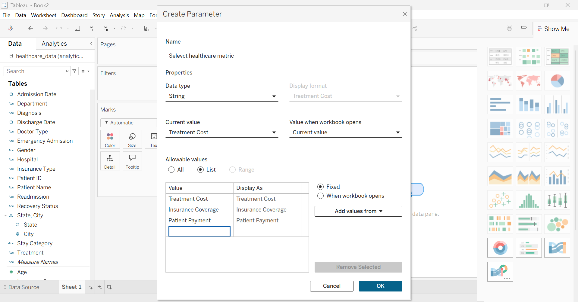
Creating the Calculation metric for the parameter
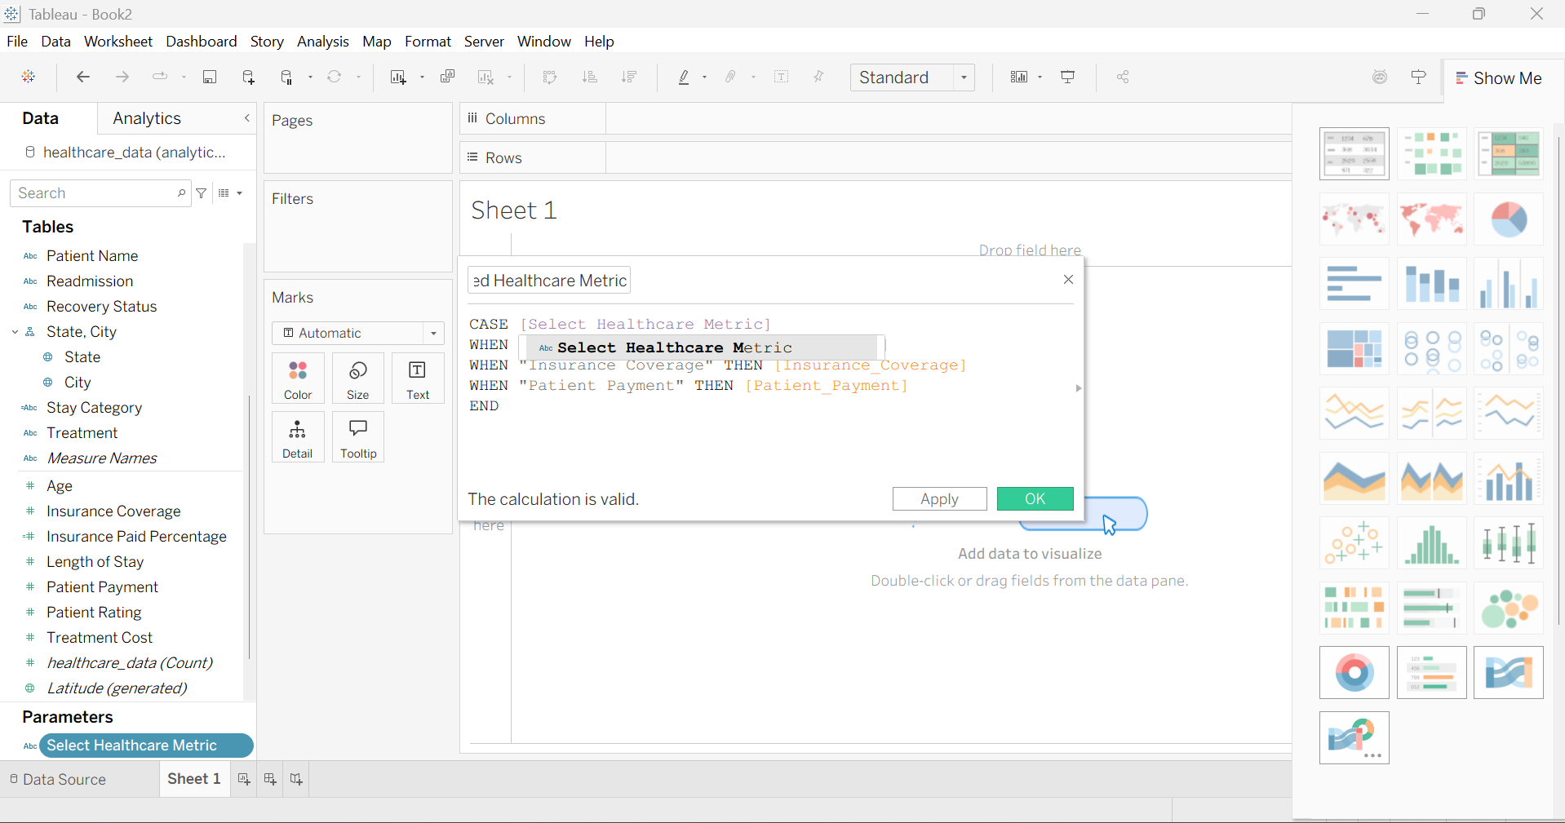
5)CREATING VISUALIZATIONS
Algorithm
- Create worksheets using appropriate dimensions and measures from the healthcare dataset.
- Use the Select Healthcare Metric parameter to dynamically compare treatment cost, insurance coverage, and patient payment.
- Create packed bubbles and a heat map to analyze department and hospital patterns.
- Create a box plot to study the distribution of treatment costs across departments.
- Create a geographical map to visualize patient ratings across states.
Output
1)Sheet 1 - Parameter-Driven bar chart:
- Treatment cost parameter
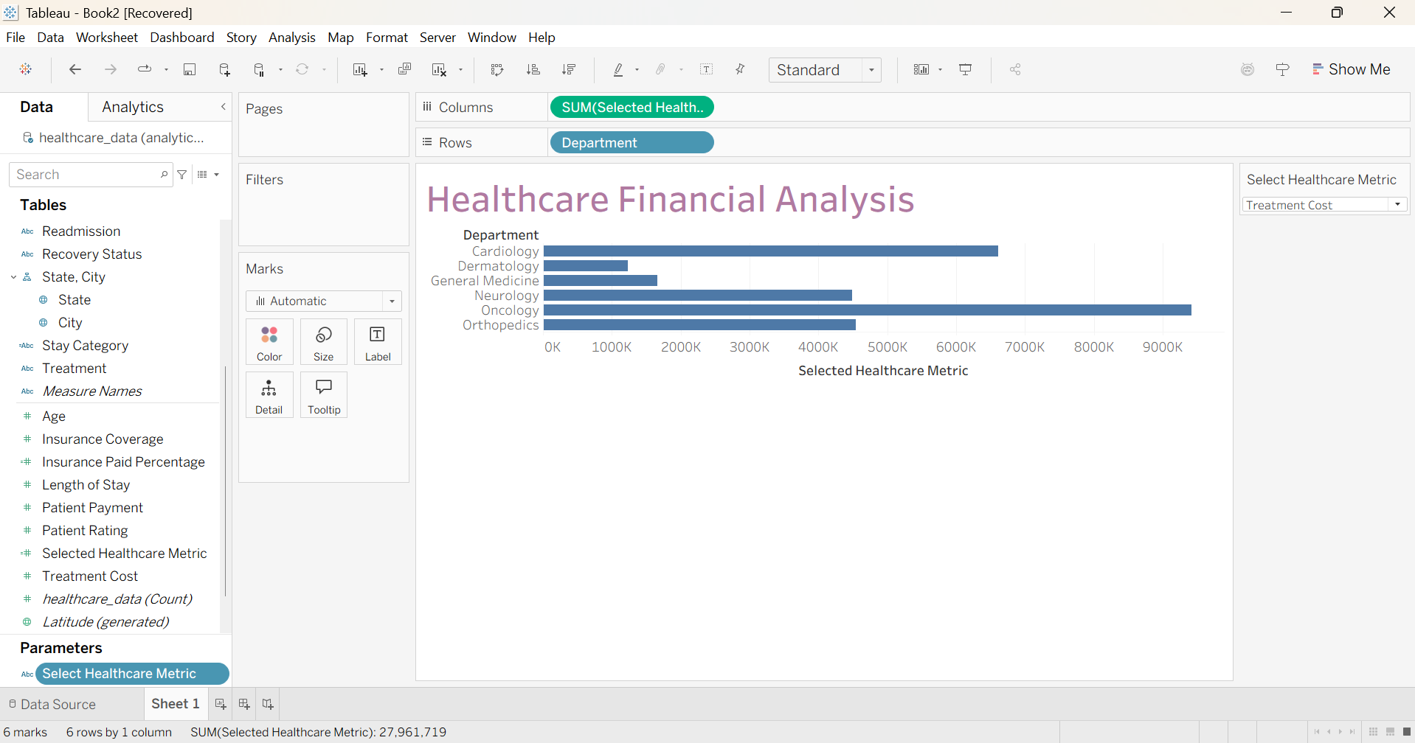
- Insurance coverage
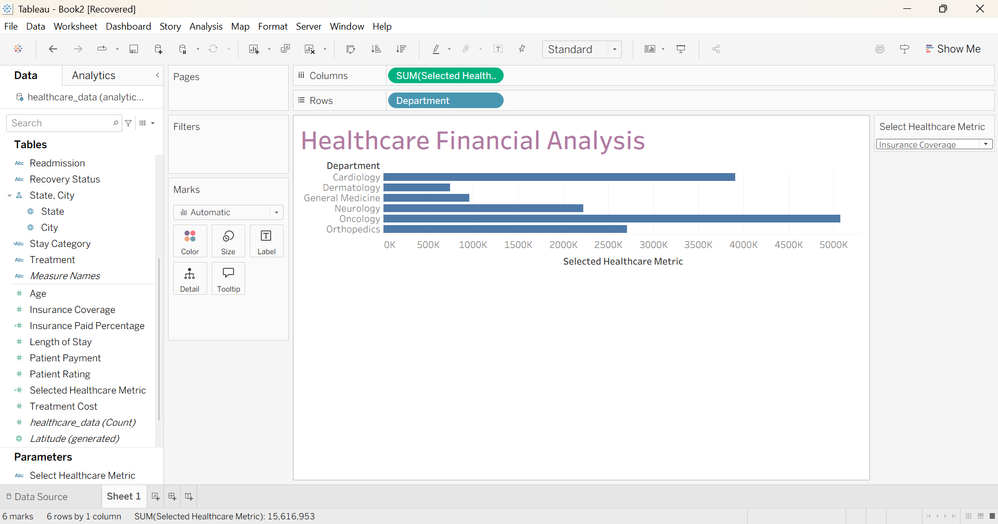
- Patient payment parameter
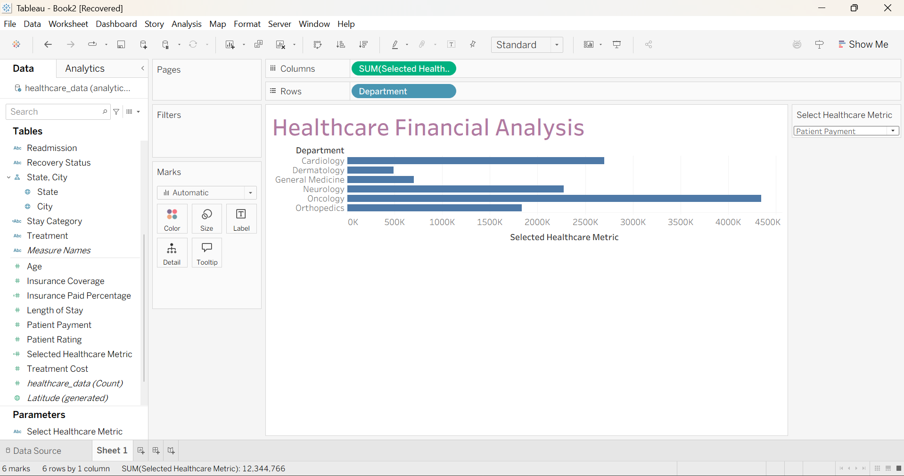
2)Sheet 2 – Packed Bubble Chart
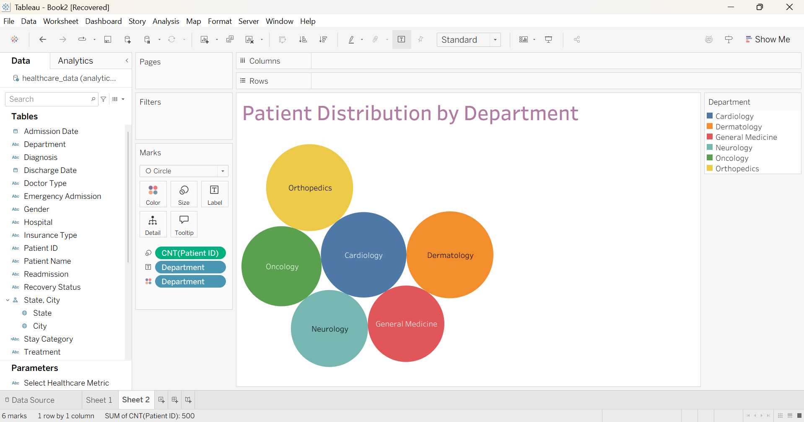
3)Sheet 3 – Recovery Status x Hospital (Heatmap)
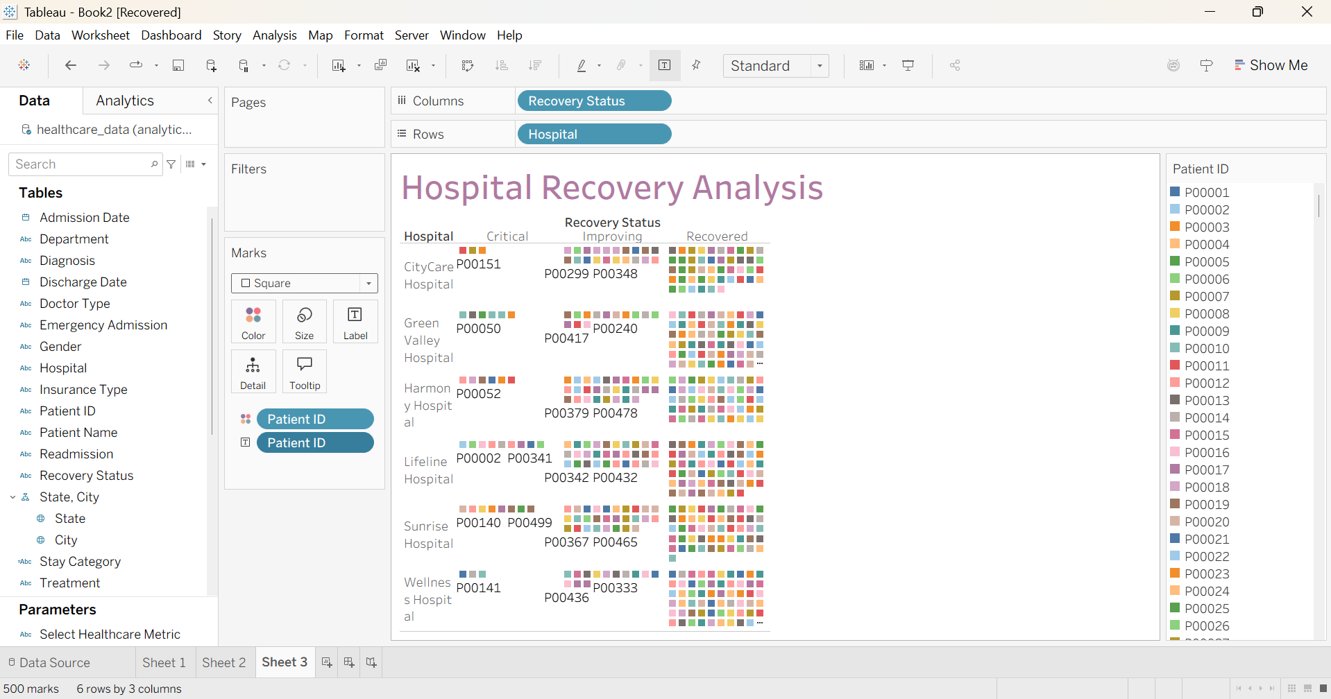
4) Sheet 4 – Treatment cost distribution
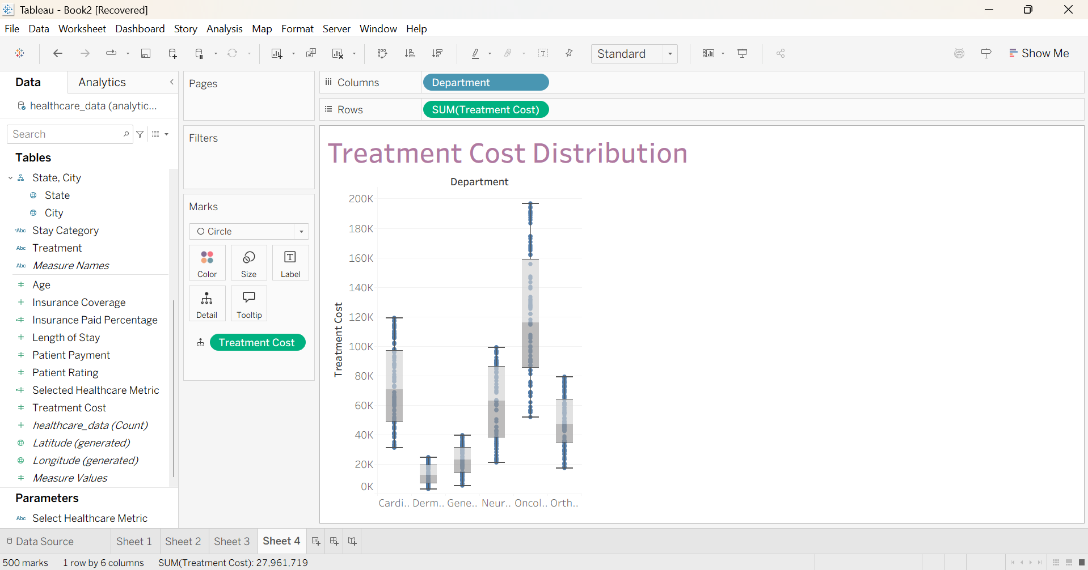
5)Sheet 5 – Patient Rating by State
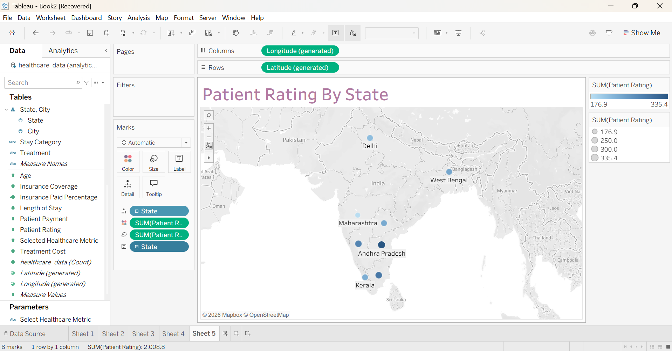
6)FILTERS
Algorithm
- Add Gender, Department, Recovery Status, and Insurance Type as filters.
- Select the required categories from the filter controls.
- Analyze healthcare data based on patient characteristics, departments, recovery outcomes, and insurance types.
Output
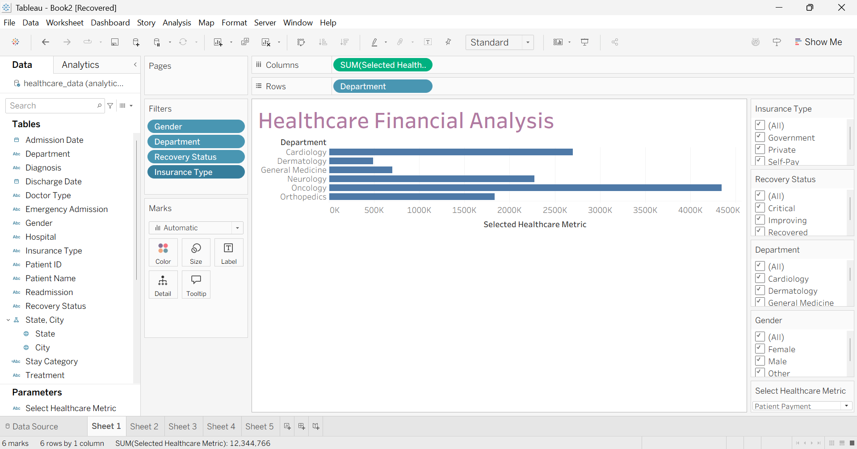
7)CREATING DASHBOARD
Algorithm
- Create a new dashboard and add the five healthcare worksheets.
- Arrange the visualizations in a suitable layout.
- Add the required filters and parameter control.
- Configure the dashboard for interactive healthcare analysis.
Output
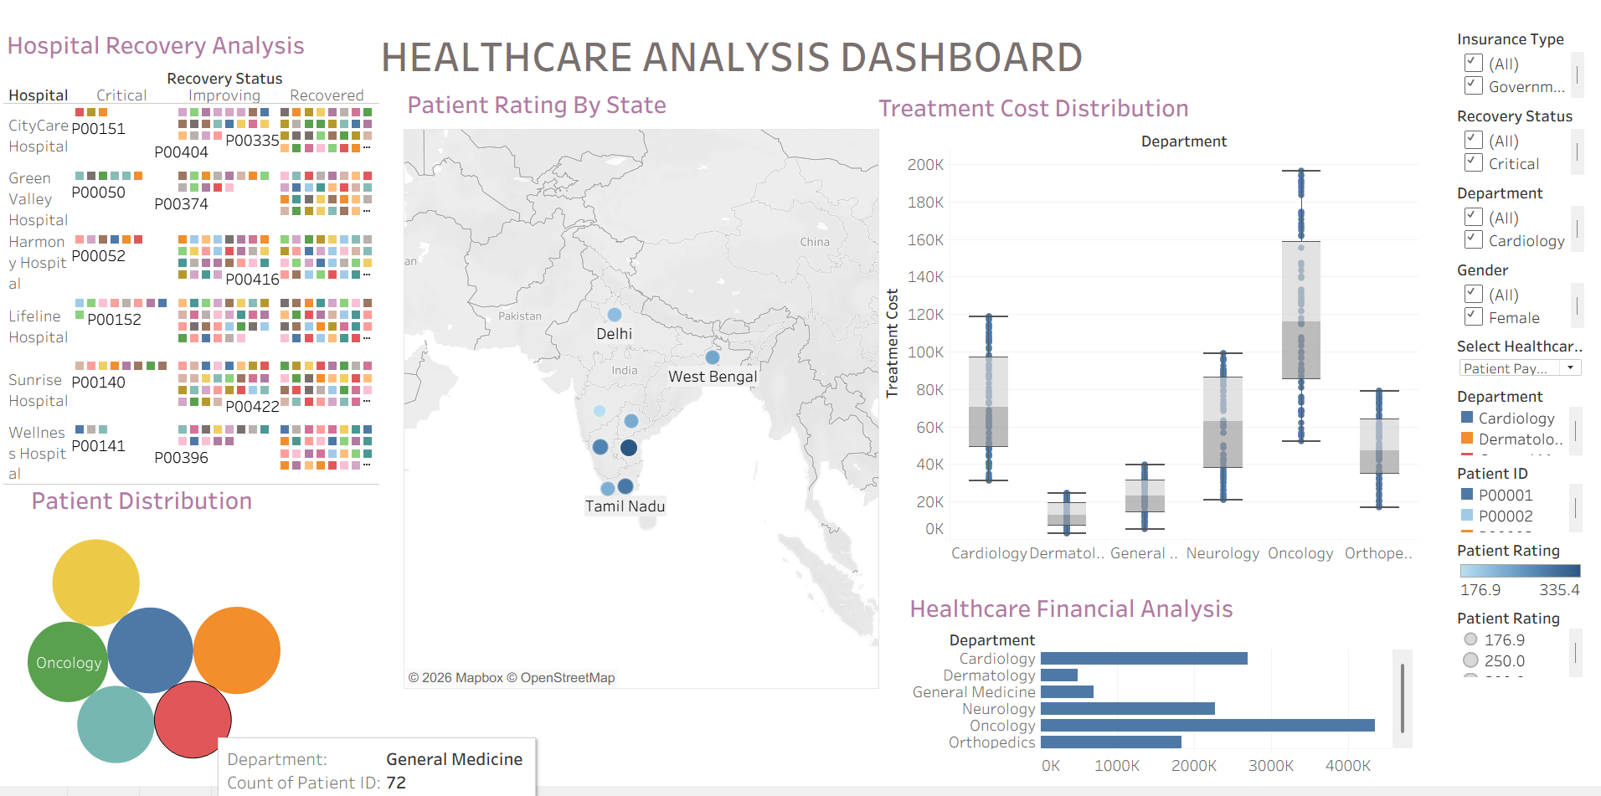

RESULT:
The healthcare dataset was successfully connected to MySQL and analyzed using Tableau. Calculated fields, parameters, filters, and interactive visualizations were created to analyze treatment costs, insurance coverage, patient distribution, hospital recovery patterns, and patient ratings. The resulting dashboard provides useful insights into healthcare performance and patient-related trends.

